**CHAPTER FOUR**

**SYSTEM IMPLEMENTATION AND TESTING**

**4.1 INTRODUCTION**

With the previously described analysis of this project, showing different tools used for design of the different modules of the system, it can finally be implemented. This chapter gives a preview on the outlook of the software. Also various modules of the software would be tested to ensure the outcome matches the initial user requirements.

**4.2 SOFTWARE TESTING**

This is a very important stage of ensuring that the system conforms to its intended requirements. It can also be used to check the quality of the system. The functionality of the software would also be tested.

**4.3 SYSTEM REVIEW**

Here, different aspects of the system would be viewed to assess the functionality. Screenshots of the system would be made available.

Below are some of the aspects of the system.

**4.3.1 HOME PAGE**





This would be the first view encountered by any user trying to access the system. It has been designed to capture the interest of anyone who tries to access the software. The home page is where all other pages pertaining to the software can be accessed easily.

**4.3.2 JEWELRY PAGE**

There are a number of pages under the homepage. One of them is the jewelry page for women. Preview of the page is shown below.





**4.3.3 THE SHOPPING CART FUNCTIONALITY**

An online shopping cart is an abstract basket which enables users to pick preferred goods and stores them temporarily till the customer is ready to checkout. This shows the total number of products picked by a user as well as the total price associated with the products.

A preview of the cart is shown below.

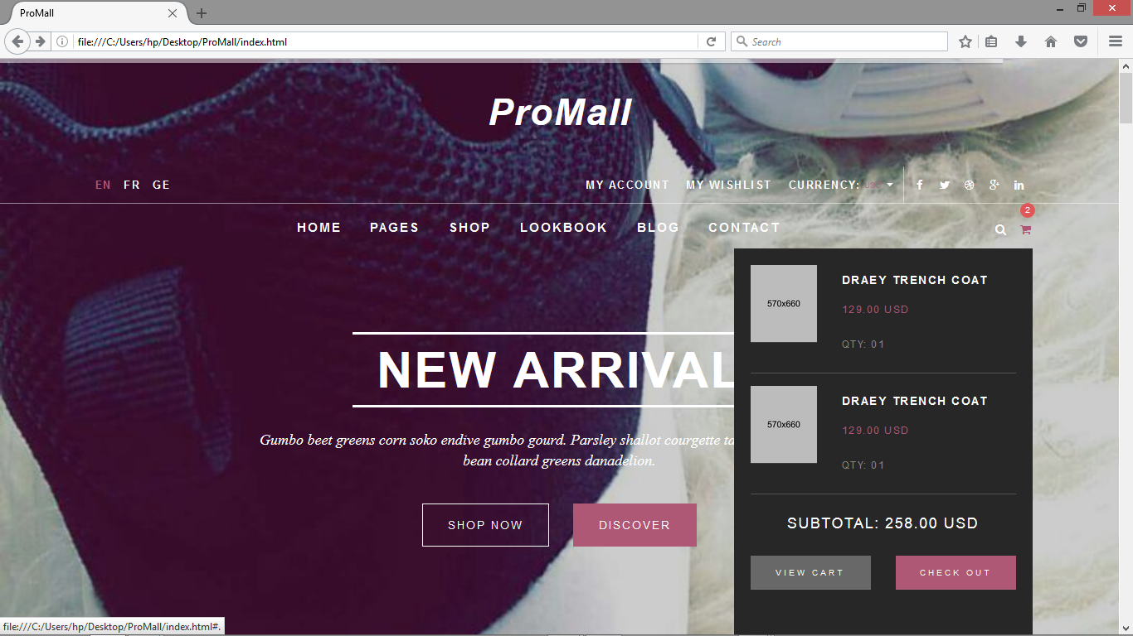

**4.3.4 SEARCH FUNCTIONALITY**

As the name suggests, this assists customers browsing through the site to easily locate desired products instead of having to go through the whole category of products.

A preview of this page would be shown below.

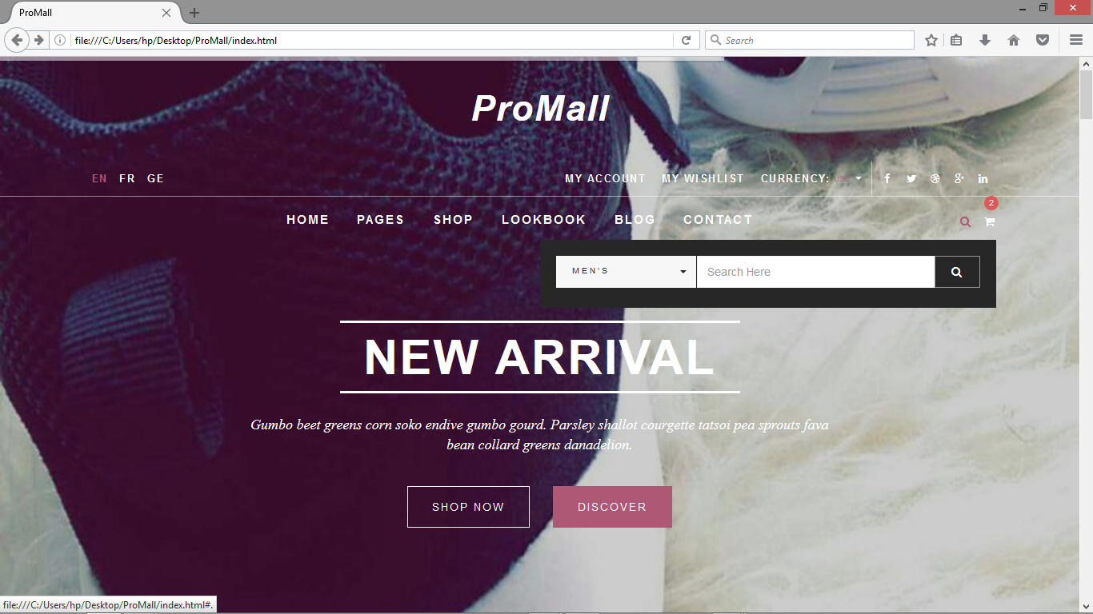

**4.3.5 ABOUT US PAGE**

This page gives sufficient information about the website and the things that make up the website. Sometimes it could also give reasons as to why the website is in place.

A preview of the about us page would be shown below.

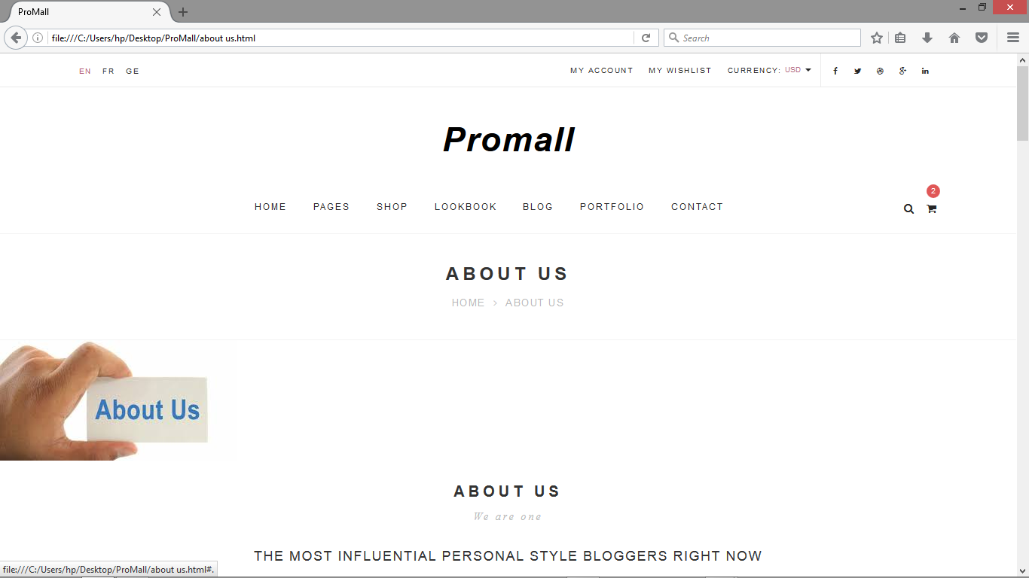

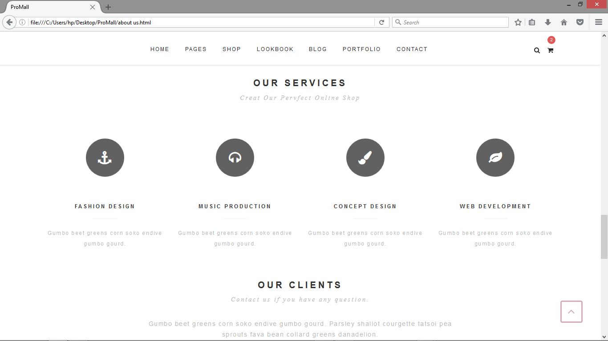

**4.4 TESTING TECHNIQUES**

These are methods that are used to evaluate distinctive parts of the system.

• **White Box Testing**

This test is used to evaluate the codes and the internal structures of the software. In most cases, this type of testing is done by the programmers themselves.

**• Black Box Testing**

This test is used to evaluate the functionality of the software without taking into consideration the internal structure. It focuses mainly on the functionality.